Vermont Coalition to End Homelessness - Coordinated Entry Committee
Monday, September 28, 9:30 – Noon
Minutes

Attendees: Sarah Phillips, Michele L SSVF/UVM, Sarah G HPC, Deb Hall, Chris Morgan, Kristin Prior, AHS Field Director, Judi Joy GSH, Dawn Butterfield Capstone, Alice Ann SSVF, Gilan VNADSV

Added to Agenda
- Examine and develop the Partnership Agreement/MOU
- Executive Summary

Rutland Check In
- Deb passed around HPC data August through September, which is a check in on what data they are tracking, planning to make some adjustments to what is tracked/how
- HPC customer service survey questions are included on sheet for partners to use/modify- collecting via phone and in person exit interview after all calls and walk ins
  - What assistance did you seek today at HPC?
  - Do you feel that you were treated well?
  - Did you receive any referrals or suggestions?
  - If yes, will you be following up on those referrals/suggestions?
  - Anything additional you’d like to add about your experience?
- What does a referral mean for HPC? Sending an email for some programs or faxing client info/intake for other programs. It depends on the agency how you make referral, currently is one sided- HPC is making referrals to the other agencies specific processes- filling out their usual application form. This is time/staff intensive.
  - Ex: Women’s network and shelter- to make a referral is to fill out their referral form
- Made a one pager about referral process, summary of services, forming local work group, building info/resource list, trying to make a connection to the direct service staff
- Flash things out in partnership agreement
- BROC still figuring out how to get their case manager who is not HOP funded to get client info into HMIS to share with HPC
- HPC is currently using a spreadsheet to track info
**Need to formalize process for referrals to agency and what the expectation is for the agencies receiving referrals are.

Washington County Check In
- GSH has reworked all internal program paperwork and screening to integrate with CE
- GSH/Capstone are meeting with ICA to discuss needs for data sharing next week
- Capstone has one central intake person who receives all referrals from GSH
- GSH sends Housing Screen with ROI to Capstone for all clients accessing GSH for informational purposes in lieu of data sharing, so Capstone knows who is being served by the shelter
- Capstone is short staffed in its housing program

ICA- HMIS Data Sharing Check In
- Planning to have Jennifer do some Service Point and Coordinated Entry demos, what is available, answer workflow questions
- Where are we at with getting the Housing Screen and Assessment into Service Point? Sarah gave the ok as VCEH representative that this is the statewide version
- We have a generally clear idea of what we want shared
**Need to call Jennifer and Adam to clarify what we want ahead of the demos

Review of the Model
- Lead Agency & Assessment partner roles and responsibilities- wait lists, Step 2 Assessment, holds MOU, etc.
- Entry Point Roles- DV, Mental health agency, soup kitchen, ESD GA- organizations who meet folks; will complete Step 1 Housing Screen that they send to the Lead Agency
- What is the role of DV providers? Special role
- Why do we make variations on the model and how? Plan welll- do not want to create many different streams (status quo)
- DV example: If DV, clients still need to be able to access the full spectrum of resources, Entry Point may make direct referral to DV agency and the client can get assessment from the agency or get referred to an Assessment Partner for the Assessment- DV is currently the only case type with a direct referral to specific agency other than the local lead
- If the DV agency the client accesses first isn’t part of CE, the person might also go to the Lead Agency and get referrals to resources there
** Need to schedule a major review of Housing Barriers Assessment now that we’ve been using it for a while
**Need to determine how referrals are handled
**Create a sample case study to show the CE process in action for someone with the map or a flow chart- Brooke will do this by the October meeting

Local Milestones for Implementation
- Create local housing inventory
- MOU partnership agreement in place
- Local CoC orientation 101 completed, maybe as a webinar in the future
- Training for partners on Step 1 and Step 2 depending on their role
- How will new agency staff be oriented/address staff turnover
- Local CoC will be using the Screening and Assessment forms daily
- Standardized ROI and process
- Definition and defined process for managing wait list- look at models, wait list management tools
- There are regular check ins on the process; workgroup of local CoC
- Consumer feedback is being received by local CoC
**When do we have a wait list? Define types of services/inventory for a wait list

Deep Dive Work Group: Partnership Agreement/MOU
Review of HPC current agreement

- Defined Roles for Local Lead, Assessment Partner, and Referral (Entry) Partners
- At what point does a partner send Step 1, Step 2 to the Lead? Within 3 days?
- What is shared with Lead Agency by Assessment Partners? Step 1-yes, Step 2- not unless Lead will be working with client or client accessing that agencies resources
- If sharing client service, share Step 1 and Step 2
- Clarification- there is a difference between a referral (client needs services) and data sharing (FYI we are working with this client)
- Data sharing- if complete assessment, scan into HMIS
- Lead agency- if making referral, they’ve done Step 1 and 2
- If served by in house service, Assessment Partner does Step 1 and 2, OR not a good fit then clear handoff process
- Add to VCEH statement and resources for the public
- Partners add something to agencies websites- public audience, brochures, etc.
- Partner’s Responsibilities- clarify what this means
- Clarify each roles with a blurb description early in the Partnership Agreement
- Add Definition section or Reference Homeless
- Make the MOU easier to read, move things around
**Need to word smith- referral partner/entry partner; coordinated entry
**Need to clarify if the Assessment Step 2 has been completed and by which agency so we are not duplicating efforts- ways to do this: HMIS, email, etc.
** Need confidentiality clarification- what level, HIPAA?
**Clarify what the report out is between the Lead and Assessment Partner
**Make a cheat sheet/process document of level of involvement communication? Communicating client outcomes or program exits? If someone is applying for a VRS, what is the process? Is there a centralized community wait list?
-To make wait list, need to do housing inventory

Serving Veterans
Examining CE model for specific sub-populations
Reviewing Veterans summary document provided by Sarah P.
Key Questions for CE Committee to Answer:
- How and Where do we identify someone as a Veteran- have you ever served?
- Discharge – at what point does it matter? At the screening level (no or later – later for sure, changes what resources are available). What is discharge status- proof/type? Need DD214 before accessing many vet services
- How are vets presenting? How do we make sure they have full access- if they come in through SSVF, how is it referring them in to the CE system so they have full access, map out the referral process (we began this)
  - MAP IT OUT – so that if a Vet starts with the VA or a Homeless Shelter or UVM then we know how they get access.
  - Do we need two processes? (no) One if clients come to the VA and one for if they come to a service provider? Is there a way to streamline?
- Is the VA an Assessment Partner? What is the VA’s role?
- What is the referral process for an immediate need- literally homeless

-VA eligible- if veteran’s program funded by VA, they must be VA eligible before they can come in, can do pending if someone says yes

Mapping: Housing Screen
=>Soup Kitchen fills out Housing Screen: Is this a Vet? Yes- where does the referral go? What do we want to happen as the process? There are 3 Options for Housing Screen referral from Soup Kitchen: to the Local Lead, VA, or to VVS/SSVF.
-If homeless/immediate need: Soup Kitchen sends referral to Lead Agency which send referral to SSVF OR emergency shelter bed

-Question: If no emergency bed, refer to SSVF, which can authorize pending Vet for a hotel bed, and gets someone to them for paperwork and to hotel
**We need an option for night time hours

=>Soup Kitchen- Housing Screen: Vet? Yes- then referred (no emergency need) to Local Lead
-Local Lead needs staff capacity to make referrals/triage
-Need an agency or person to make sure the person does not fall through the gaps- soup kitchen doesn’t have staff/limited capacity, need someone as advocate
-Assessment Partner process may be different for referrals/immediate need than the Referral Partners

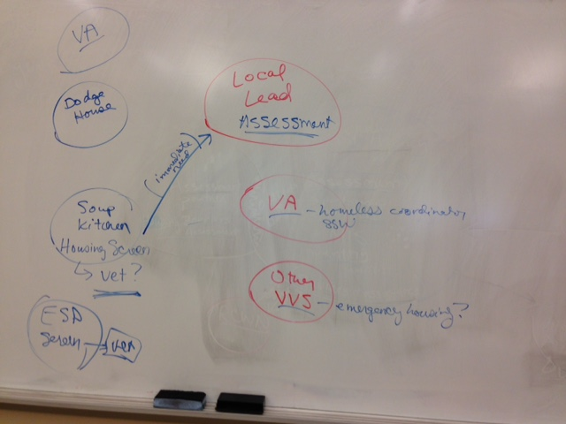

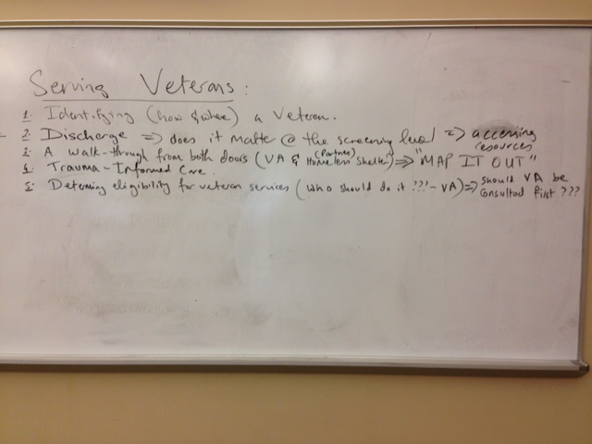

October Web Meeting: Monday 10/26 10:30 to Noon

