**VCEH Coordinated Entry Committee**

**11.28.16 Minutes**

Sarah Phillips, OEO; Bethany & Ari, VCRHYP, Heather, Groundworks; Joe LeClair, Samaritan House; Doug Sinclair, Charter House; Renee Weeks, Upper Valley Haven; Brian Smith, DMH; Kara Casey, VNADSV; Andrea & Theresa, AHS Americorps VISTAs; Brooke Jenkins, Good Samaritan Haven; Amos Meacham, Pathways; Caitlin & Megan, ICA/HMIS; Deb Hall & Sarah, Homelessness Prevention Center

10:10am Begin/Introductions: ROI, Update on Staff confidentiality, Workflow mapping, Brooke made a mapflow for

Stuck at We have done the assessment and NOW WHAT? Work through some different possibilities of working through that

Incorporate HRT, options on how they play roles.

Moving forward the permanent supportive housing

10:15am:

* ROI: went through and approved by VCEH. If there are any changes/additions (Brattleboro wanted to highlight it is voluntary to sign at the top/Decline the ROI) need to go through VCEH. Start using this ASAP, 3 months to make the adjustments:
* -Mental health and substance abuse: Has some people cautious because it has to do with some medical. Things such as case-notes would not be shared.
* Are people going to be trained on how to use this?? – Steps to the process, partnership agreement needs to be in place. HMIS data sharing agreement, Staff confidential training/policies/need to know still applies.
* Script or checklist on how to present to the client. What do we want to have conversation with the client for consistency. How do you have a conversation with someone and feel comfortable. Pointers for people as a training tool.
* How can we explain these to people with disabilities?
* Future item: developmental council to possibly look into this. Poster explaining data share? Too much information is overwhelming as well. A good way to explain.

10:30am: Staff Confidentiality: Alexa (VISTA Burlington/Chittenden) Webinar series training. General policies and principals. Appendix to partnership agreement.

1 page overview that is for the client to understand rights.

10:41am: Workflow

Washington County Overview of Workflow map that Brooke Created

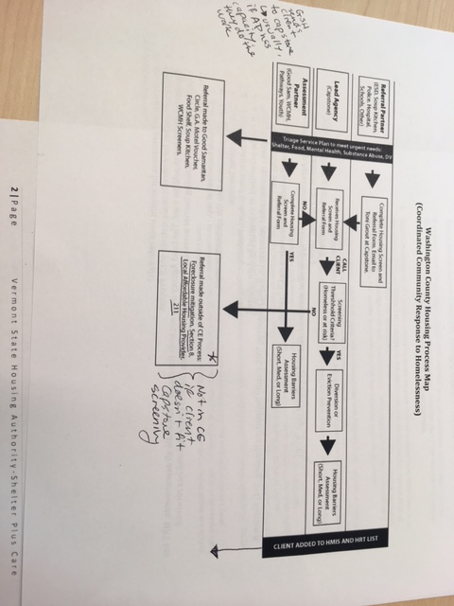

Where were you before you came here?

Seasonal shelters that are separate, are they involved in Coordinated Entry? Most seasonal shelters are thinking about it (Assessment partners)

Can a referral partner send someone to an assessment person because they know that the resources needed. Decision on where to send someone is made not immediately. Daily meeting about who they met with that day and where is the best place for this person

It depends on what the client tells you at the moment. (Screening)

Assessment is usually complete before housing.

Discussion/Questions from Brookes Worksheet:

1. Are there other processes for urgent need referrals?
2. Create info packet for referrals made outside of CE process
3. Discuss how HRT list should be used. The Lead Agency does not have the capacity to handle all assessments. HRT list could be used to track housing barrier assessments and monitor whether client is connected and has received resources:
   1. List chronic homeless at top
   2. Add everyone came into the system this week.
   3. Include housing barriers
   4. Include whether need is short/med/long term
   5. List can be prioritized or organized by date referred.
   6. Suggest plan- recommended resource: rapid rehousing, vrs, family supportive housing, s+c, section 8, WCMH housing ect.
4. Provide training for all housing case managers on CE system
5. TO DO:
   1. Partnership Agreement has been approved at state level All Partners should sign (OCT
   2. Sign CE ROI (Nove)
   3. Sign Data Sharing Agreement (Dec)

How do HRT fit into the roles of CE? Where would they makes sense?

**Workflow Mapping**

Track but not send: Do we want to/how do we track the fact that this housing screen is being done?

Assessment Partner Report:

How many: Screenings, Assessments.

* Monthly report of how many screenings were done, how many assessments were done, This would be for partner report
* Assess how many times a person has done a screening/assessment Client based

List on HMIS, filter how you want to search for who you can take? How long will a person stay on this list before they are booted off? How does one get taken off the list? Won’t this make it difficult for some people to get help? We are not only relying on this list correct?

Shelter Plus Care: People who have the highest need (based on pre-determined criteria/indicators) are served first.

Prioritized lists to choose from HMIS? Excel? How to get DV on there? Kara Casey has some ideas of how we can do this with unique identifiers.

Choosing from the top of the list, if you do not take the person at the top need a reason?

Multiple lists should be made, DV, Veteran, Chronic, Children, Families

How to manage the List: HRT can be a place for list review? Lead Agency can manage? Agencies should be able to “pull” from list between meetings to serve clients.

**12:10: Guidance for Prioritization of PSH (VCEH CE)**

We reviewed past discussion of PSH prioritization

Chronically homeless, then Non-chronically homeless

Substance abuse, mental health, police: They are a small area of people, but they typically use the most resources. Do we want to consider “frequent service users” as a way to determine those with the “most Severe Service needs”