Occupancy Fee Bill
The Housing For All Coalition supports the creation and passage of an Occupancy Fee Bill in the 2017 Legislative Session.
We are asking that all revenues from this fee go toward affordable housing and homelessness reduction in Vermont. This would include investment in the creation of permanently affordable housing, increased rental assistance and supportive services- incorporating the outcomes and recommendations from the legislatively funded Roadmap to End Homelessness to help make this determination.
By charging $2/night for each night of occupancy (under 30 consecutive days) on any hotel as defined in Reg. § 1.9202(3) it is estimated that an Occupancy Fee will raise approximately $11-$12 million per year.
Why housing?
In Vermont:
88 hrs per week at minimum wage needed to afford a 2-bedroom unit
2.2 number of full time jobs needed at minimum wage needed to afford a 2-bedroom unit
$21.13 per hour wage needed to afford a 2-bedroom unit¹

Access to safe, affordable housing is a basic need and right for all Vermonters. When Vermont families have a safe place to call home, our communities and our state are healthier. Gov. Shumlin and AHS Secretary Hal Cohen recognized this in 2015 when they launched a statewide initiative to End Child and Family Homelessness by 2020. Vermont’s recent efforts to end homelessness have been successful - as seen in the 2016 Point-in-Time Count which showed a 28% reduction in homelessness, but there is still work to be done. Revenue from an Occupancy Fee would help to further reduce homelessness and other barriers to housing such as affordability and lack of housing stock.

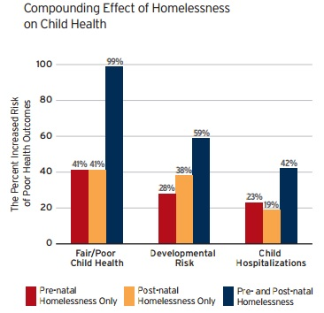
By creating more housing options, we are encouraging families to live in Vermont, creating more jobs and ensuring that Vermonters have the stability they need to be thriving members of our Vermont economy. Reducing or eliminating homelessness and housing insecurity will help our families and our state to thrive.

For more information or to get involved please contact Kara Casey at (802) 223-1302 or kara@vtnetwork.org

