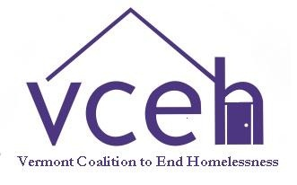
Looking for Help to Get or Keep Housing?
Call the Lead Agency in Your Area to Get Connected

Addison County:
Charter House
Doug Sinclair
jdsinclair@ripton-coop.net
(802) 989-9746

Bennington County:
BROC – Community Action in Southwestern Vt
Beth Johnson
ejohnson@broc.org
(802) 445-7515

Brattleboro Area:
Groundworks Collaborative
Karli Schrade
kschrade@groundworksvt.org
(802) 257-5415

Caledonia, Essex, Orleans Counties:
Northeast Kingdom Community Action
Newport
Kathy Griffin
kmetras@nekcavt.org
(802) 334-7316

St. Johnsbury
Jillian Ruggles
jruggles@nekcavt.org
(802) 748-6040

Chittenden County:
Champlain Valley Office of Economic Opportunity
Chris Brzovic
cbrzovic@cvoeo.org
(802) 863-6248 x723 or (802) 318-2326

Franklin/Grand Isle Counties:
Champlain Valley Office of Economic Opportunity (CVOEO)
Robert Ostermeyer
rostermeyer@cvoeo.org
(802) 527-7392

Hartford Area:
Upper Valley Haven
Becky Hadley
bhadley@uppervalleyhaven.org
(802) 295-6500

Lamoille County:
Pat Turner
pturner@capstonevt.org
(802) 888-7993 or (800) 639-8710

Rutland County:
Homeless Prevention Center
Sara Lynn Schoenwetter
saralynn@hpcvt.org
(802) 775-9286

Springfield Area:
Springfield Supported Housing
Kathleen Sargent
kathleen@sshp.vermontel.net
(802) 885-3034

Washington County:
Capstone Community Action
Toni Grout
tgrout@capstonevt.org
(802) 477-5242 or 1-800-639-1053

Looking for a warm, safe place to sleep tonight?
Call 2-1-1 to find a shelter near you

