Venue | Location | Available 3rd Tues 10-3? | Cost | Technology | Capacity | Notes
St. John’s Church | Randolph | Yes | $25-30 | Wifi? Yes  Projector? No  Phone? No
Randolph Town Hall | Randolph | Yes. Book in advance and confirm the Wed of week before by noon | Free | Wifi? Yes  Projector? No  Phone? No | STRICT maximum capacity of 40
Hartford Town Hall | Hartford | Yes. Book in advance. | $25 | Wifi? Yes  Projector? Yes  Phone? Yes | Capacity with tables is about 35, possible to have more without tables | 25 mins south of Randolph
RRTC Classroom | Northfield | Yes | Free | Wifi? No  Projector? Yes  Phone? Yes | 40 | 20 mins north of Randolph

Does not work:
- Gifford Medical Center: Does not have capacity for over 25 and not consistent space
- Vermont Law School: Expensive and need to schedule around classes
- Norwich University: not possible during the day to have a consistent space
- Randolph Library: meeting space is within the library bookshelf space
- Vermont Tech Enterprise Center: only comfortably holds 20 people
- Vermont Technical College: classrooms inconsistent or $300/day for conference space

Did not hear back from Chandler

Hartford Town Hall Meeting Space
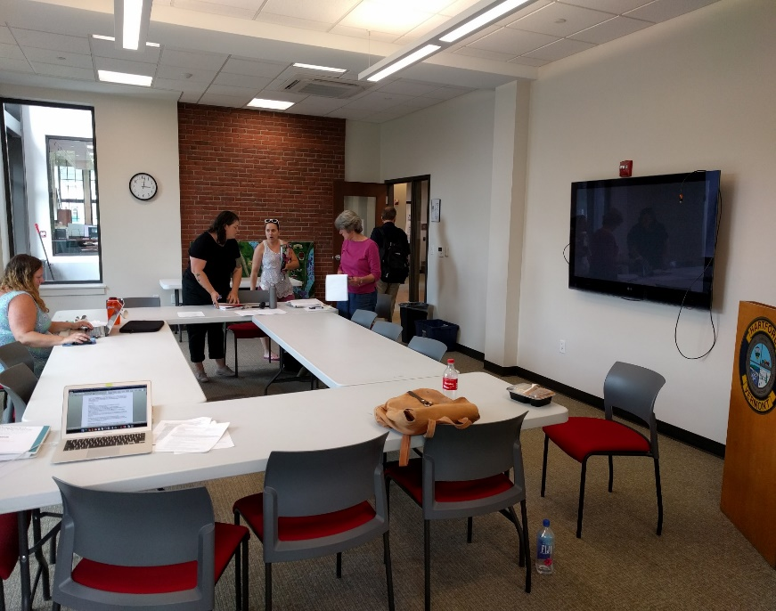
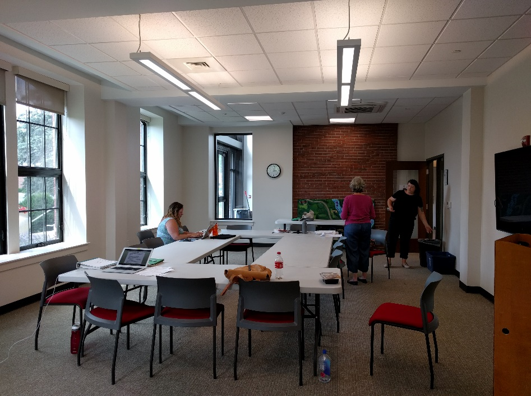

Randolph Town Hall Meeting Space
